**RAMAIAH INSTITUTE OF TECHNOLOGY**

(Autonomous Institute, Affiliated to VTU)

Accredited by National Board of Accreditation & NAAC with 8A+9 Grade MSR Nagar, MSRIT Post, Bangalore-560054

[www.msrit.edu](http://www.msrit.edu/)

**2025**

**Department of**

**Master of Computer Applications**

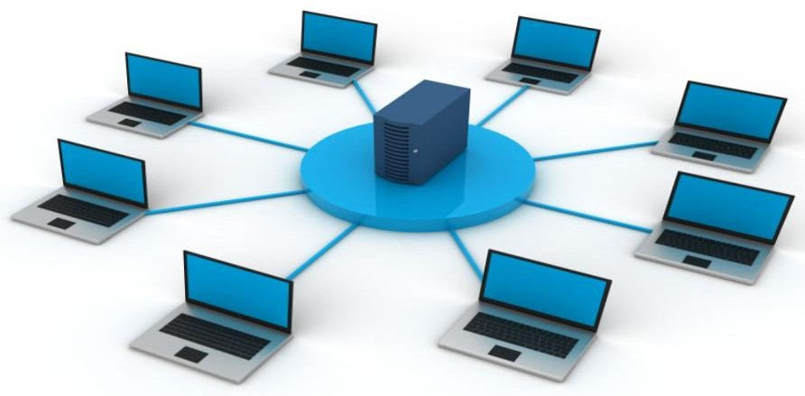

**Assignment-1 COMPUTER NETWORKS**

**MCA24**

**TRIVIAL FILE TRANSFER PROTOCOL(TFTP) PROTOCOL FOR IOS BACKUP AND RESTORE.**

|  |
| --- |
| **NAME: CHASHMITHA T S** |
| **USN: 1MS24MC021** |
| **ACADEMIC YEAR: 2024-2025** |

**Table** **of** **Contents**

1. **Abstract** **1**
2. **Introduction** **2**
3. **Objective** **3**
4. **Literature Review** **4**
5. **Implementation** **and** **Methodology** **5-8**
6. **Commands** **to** **Setup** **9-10**
7. **Results** **and** **Analysis** **11**
8. **Conclusion** **and** **Future** **Work** **12**
9. **References** **13**

# Abstract

In modern network environments, maintaining reliable configuration backups is essential to ensure operational continuity and rapid recovery during device failures or misconfigurations. The Trivial File Transfer Protocol (TFTP) offers a simple yet effective method for transferring configuration files between network devices and centralized servers. TFTP operates over UDP and is widely supported on Cisco routers, making it a practical solution for routine administrative tasks like backing up and restoring device configurations or transferring IOS images. Unlike more complex protocols, TFTP requires minimal setup, making it ideal for small-to-medium-sized network environments where simplicity and speed are prioritized.

This assignment explores the configuration and usage of the TFTP protocol for backing up and restoring a Cisco router’s running configuration. The implementation consists of a basic two-device topology involving a router and a PC configured as a TFTP server. Commands such as copy running-config tftp: and copy tftp: running-config are used to perform the backup and restore operations respectively. The process demonstrates how a network administrator can preserve current configurations before major changes and retrieve them later if needed. The simulation is performed using Cisco Packet Tracer, providing a hands-on experience of how TFTP facilitates crucial configuration management tasks.

By successfully completing the backup and restore procedures using TFTP, the assignment confirms the protocol’s efficiency and relevance in network maintenance workflows. Though TFTP lacks advanced features such as encryption and authentication, its lightweight nature and ease of deployment make it a valuable tool in controlled environments. The experience gained from this setup enhances understanding of network device management and highlights the importance of integrating regular backups into an organization's operational strategy.

# Introduction

In any computer network, especially one comprising routers and switches from Cisco or other enterprise vendors, configuration management is a critical responsibility. Network administrators must frequently update settings, modify routing policies, or perform firmware upgrades—all of which involve the risk of misconfiguration or failure. In such cases, having a recent backup of the device's configuration can save valuable time and effort. The ability to restore a router to a known good state without manually re-entering every command not only reduces downtime but also improves reliability and operational efficiency. One of the most straightforward methods to perform such backups is by using the Trivial File Transfer Protocol (TFTP), which enables devices to transfer files over the network using minimal configuration.

TFTP is a lightweight, connectionless protocol that uses UDP on port 69 to transfer files between a client and a server. Unlike its more complex counterpart FTP, TFTP does not require authentication and does not provide directory browsing or advanced access control. Its simplicity makes it ideal for quick tasks such as uploading a router’s running-config file to a TFTP server or retrieving saved configurations to restore on a replacement device. In Cisco networking environments, TFTP is commonly used not only for configuration backups but also for upgrading the IOS image of a router or switch. Despite its limitations in terms of security, TFTP is still preferred in many internal network setups, especially where a simple, efficient method of configuration transfer is required without the overhead of encryption or login credentials.

In this assignment, we demonstrate the practical use of TFTP by simulating a scenario in which a router’s configuration is backed up to a PC acting as a TFTP server, and later restored from the same server. This process involves setting up proper IP connectivity, enabling the TFTP service on the PC, and executing the appropriate copy commands from the router CLI. Tools like Cisco Packet Tracer make it easy to replicate this process in a virtual lab environment, allowing students and network administrators to gain hands-on experience. The ease of implementation, combined with its practical utility, makes TFTP an essential protocol in any network administrator’s toolkit, especially when it comes to maintaining consistent device configurations and ensuring operational resilience.

# Objective

The primary objective of this assignment is to demonstrate how the Trivial File Transfer Protocol (TFTP) can be utilized to effectively manage the backup and restoration of Cisco router configurations. In the lifecycle of network devices, configurations are frequently changed to accommodate new services, security policies, or infrastructure upgrades. Any unintended change or misconfiguration can result in service outages, which may impact business continuity. Therefore, having a reliable and accessible method to back up running configurations becomes essential. This assignment focuses on simulating that real-world scenario, where the current configuration is saved externally and can be restored when needed, reducing downtime and improving administrative efficiency.

Another key goal is to ensure students gain hands-on experience with fundamental networking protocols and command-line tools, particularly in using Cisco IOS to interact with external servers. The exercise requires configuring both the router and a TFTP server (typically a PC with TFTP functionality enabled) to facilitate the file transfer. The objective is not only to back up the running configuration but also to validate that the restored configuration accurately replicates the previous device state. This includes preserving interface settings, routing protocols, access lists, and hostname information. Through this practical activity, students become familiar with copy commands in IOS, understand the significance of maintaining configuration versions, and learn how to avoid manual reconfiguration.

A final objective of the assignment is to highlight the practical importance of TFTP in small- to medium-scale network environments where simplicity and quick deployment are preferred over complexity and overhead. While more secure methods like SCP or SFTP exist, they often require additional authentication infrastructure, which may not be available in all environments. TFTP serves as a low-resource solution ideal for internal or lab networks. By completing this assignment, students will understand when and where to appropriately use TFTP, how to verify a successful backup or restore process, and how this protocol fits into broader configuration management practices in professional networking environments.

# Literature Review

Configuration backup and restore procedures are foundational components of network administration and are widely recommended by industry best practices and certifications like CCNA, CompTIA Network+, and Cisco Certified CyberOps Associate. Cisco's official documentation, as well as numerous practical training resources, consistently highlight the use of TFTP as a reliable and straightforward method for transferring configuration files and IOS images between devices. The command-line integration of TFTP within Cisco IOS allows for seamless interaction with TFTP servers without requiring third-party tools or complex configurations. For this reason, TFTP remains an essential protocol in both enterprise and educational lab environments.

The origins of TFTP date back to its formal specification in **RFC 1350**, which defines it as a minimalistic protocol designed to allow simple file transfers without the overhead of a full-featured protocol like FTP. Because it uses UDP and does not include built-in security, TFTP is best suited for use within secured or isolated networks where speed and simplicity are prioritized. Despite its limitations, the protocol's lightweight nature and lack of authentication requirements have made it a popular choice for firmware upgrades, configuration transfers, and system provisioning in embedded systems and routers. In Cisco environments, TFTP is often deployed in conjunction with tools like SolarWinds TFTP Server, TFTPD32, or even the built-in TFTP service in simulation tools like Cisco Packet Tracer and GNS3.

Various studies and technical tutorials have documented the application of TFTP for both academic and enterprise purposes. For example, in Cisco’s Networking Academy lab manuals, exercises often include using TFTP to transfer IOS images or restore device settings to demonstrate how easily configuration drift or failures can be mitigated with minimal effort. Additionally, research in network automation and orchestration emphasizes that automated backup tools often rely on TFTP or similar lightweight protocols to gather device configurations across networks. In managed service provider (MSP) environments, scripts routinely invoke TFTP-based backups during scheduled maintenance windows. The consistency and predictability of the protocol make it ideal for integration into larger network management frameworks, while still being accessible for manual use by entry-level network technicians.

# Implementation and Methodology

# 

# The implementation of TFTP-based configuration backup and restore in a Cisco network involves the interaction between a network device (a Cisco router in this case) and a TFTP server (hosted on a PC). This section explains the logical structure, IP addressing, TFTP service setup, command-line interactions, and troubleshooting considerations for successful deployment. The topology is minimal by design—consisting of only one router (R1) and one PC—to ensure focus remains on mastering the TFTP file transfer process rather than handling complex routing scenarios.

# 1. Topology Design and IP Configuration

# The first step is to establish basic connectivity between the router and the PC. The PC acts as the TFTP server and is assigned an IP address of 192.168.1.10/24. The router’s GigabitEthernet0/0 interface is configured with the IP address 192.168.1.1/24, placing both devices in the same subnet. This ensures Layer 3 connectivity without requiring routing protocols or additional interfaces. After configuration, a basic connectivity test is conducted using the ping command from the router to the PC. If the ping fails, it indicates either IP misconfiguration, a firewall block on the PC, or a down interface.

# 2. Enabling and Testing the TFTP Server

# The PC is configured to run a TFTP server application. In simulation environments like Cisco Packet Tracer, this is built-in and enabled from the Services tab under TFTP. In real-world scenarios, lightweight tools like Tftpd32 or SolarWinds TFTP Server can be installed and run with minimal configuration. The TFTP root directory is selected, where files transferred from the router will be stored and from where configuration files can be retrieved. The TFTP service must be running and listening on UDP port 69. No authentication or encryption is required, which reduces overhead but also limits TFTP to trusted internal networks.

# To test the TFTP server's readiness, the router executes the command:

# copy running-config tftp:

# The IOS prompts the user for the IP address of the TFTP server and a destination filename. If the file transfer is successful, a “successfully copied” message is displayed, and the file appears in the TFTP server’s storage path.

# 3. Backup Procedure

# Before making any changes to the router’s configuration, the current running configuration is saved to the TFTP server. This is a preventive measure in case new changes cause the router to become unreachable or misconfigured. The command used is:

# CopyEdit

# copy running-config tftp:

# This command triggers a file upload from the router's RAM (running-config) to the remote TFTP server. The file is saved under the specified name, such as R1-backup-config, and can be viewed and inspected manually using any text editor since Cisco configuration files are plain text.

# 4. Restore Procedure

# To simulate a real-world failure or rollback scenario, the router’s configuration is either erased using write erase or replaced by another configuration. To restore the original settings from the TFTP server, the following command is used:

# CopyEdit

# copy tftp: running-config

# The user specifies the IP address of the TFTP server and the previously saved filename. Upon successful transfer, the router immediately applies the restored settings to the running configuration. This includes interface IPs, hostnames, routing protocols, and access lists—essentially reverting the device to its previous known state. It’s important to re-save the configuration using copy running-config startup-config to retain the settings after reboot.

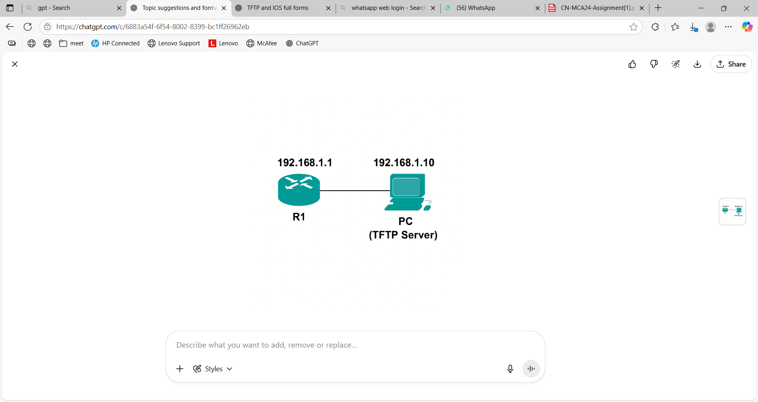

**Fig 3.1: Network Topology**

The network topology for this assignment is deliberately simple, focusing solely on the interaction between a Cisco router (R1) and a PC configured as a TFTP server. This setup simulates a real-world scenario where an administrator backs up and restores router configurations across a local network.

**🔹 Components:**

* **Router R1:** This device represents any Cisco router whose configuration we want to back up or restore.
* **PC (TFTP Server):** A personal computer running a TFTP server application (built-in in Packet Tracer or external software like Tftpd32). It acts as the backup destination and source.
* **Connection:** The router and PC are connected via a straight-through Ethernet cable to ensure direct Layer 2 and Layer 3 communication.

**🔹 IP Addressing Scheme:**

* **Router R1 GigabitEthernet0/0:** 192.168.1.1/24
* **PC (TFTP Server):** 192.168.1.10/24

Since both devices reside in the same subnet, no routing configuration is necessary—simple IP connectivity is sufficient. This allows the router to reach the TFTP server using basic ICMP (ping) and UDP for file transfer.

**Commands to Setup:**

**Router R1 Configuration**

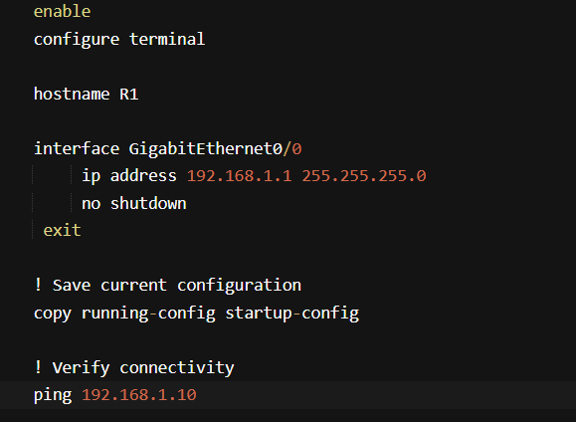

**On the PC (TFTP Server)**

In **Cisco Packet Tracer**:

* Open the PC → Go to **Services** tab → Click **TFTP** → Ensure the service is ON.

In **real setup**:

* Run **Tftpd32**, **SolarWinds TFTP Server**, or equivalent.
* Set the root folder where config files will be saved.

**Verify Interface and Connectivity**

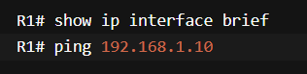

**Save the Configuration Before Backup:**



**Backup the Configuration to the TFTP Server:**

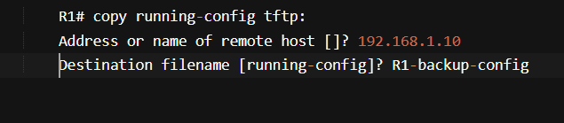

This transfers the configuration to the TFTP server and saves it as R1-backup-config

**Restore the Configuration from the TFTP Server**

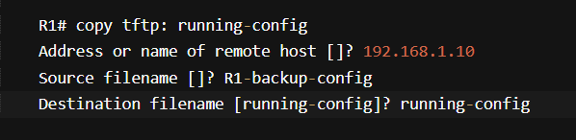

**Make sure the TFTP service is enabled and running on the PC with IP 192.168.1.10.**

**Results and Analysis**

After performing the backup and restoration process, several validations are conducted to confirm functionality:

**Backup Validation**

Upon issuing the copy running-config tftp: command, the router contacted the TFTP server (192.168.1.10) successfully. The server log displayed that a file named R1-backup-config had been received and stored in its default directory. On inspection, the file contained the router's complete configuration including hostname, interface IPs, and any routing or security settings.

**Restore Validation**

To test the restoration process, the router’s configuration was cleared using write erase, followed by a reload. The restored configuration from the TFTP server using copy tftp: running-config immediately reapplied the previous setup. Verification through show running-config confirmed that all settings were restored accurately, including the hostname “R1” and the interface configuration for GigabitEthernet0/0.

**Connectivity Testing**

Post-restoration, a ping test from the router to the PC confirmed restored connectivity. The router was also able to initiate another TFTP backup to ensure continued file transfer capability. This double verification confirmed that both the backup and restore mechanisms were functional.

**Analysis**

This process demonstrated that TFTP is a reliable and efficient way to manage configuration files in a Cisco network. While it lacks encryption and authentication, the simplicity and speed of the protocol make it suitable for internal, trusted networks. This hands-on lab highlights the importance of maintaining regular backups and reinforces the necessity of testing restore procedures as part of disaster recovery planning.

# Conclusion And Future Work

This assignment effectively demonstrated the use of the Trivial File Transfer Protocol (TFTP) for backing up and restoring configuration files on Cisco routers. The simple yet powerful capability of TFTP to transfer configuration files across a network was explored through practical implementation using a minimal topology consisting of a single router and a TFTP-enabled PC. By configuring basic IP connectivity and executing a few IOS commands, the router's running configuration was successfully backed up to the TFTP server and later restored to its original state. This validated TFTP’s role as a reliable and efficient tool for configuration management in small and medium-sized networks.

The exercise also emphasized the importance of proactive configuration backup strategies in network administration. In real-world environments, changes to router or switch configurations are frequent, and the ability to quickly roll back to a known working state can prevent costly downtime. TFTP provides a fast, low-overhead solution for such scenarios, particularly when security concerns are minimal or the network is well-isolated. Although TFTP lacks features like encryption or user authentication, its simplicity and native support in Cisco IOS make it ideal for use in internal, trusted environments or lab simulations. Moreover, the backup and restore procedure highlighted the usefulness of automation and scheduled backups, which are essential for consistent network reliability.

In the future, this implementation can be expanded to include more advanced use cases. One possible direction is integrating TFTP with network automation tools to perform scheduled or triggered backups across multiple devices. Another enhancement would be the use of secure alternatives such as SCP (Secure Copy Protocol) or FTP over TLS in production networks, where data confidentiality is critical. Additionally, thisss basic topology could be scaled to include multiple routers, centralized TFTP servers, and version control systems to simulate enterprise-grade configuration management systems. This assignment serves as a foundation for deeper exploration into network backup automation, disaster recovery planning, and secure file transfer practices.

# References

[1] Cisco Systems, Cisco IOS Configuration Fundamentals Command Reference.  
 [Online]. Available: <https://www.cisco.com>

[2] RFC 1350 - The TFTP Protocol (Revision 2).  
 [Online]. Available: <https://datatracker.ietf.org/doc/html/rfc1350>

[3] Cisco Networking Academy, Introduction to Networks v7.0 Course Material.  
 [Online]. Available: <https://www.netacad.com>

[4] Todd Lammle, CCNA 200-301 Official Cert Guide, Wiley Publishing, 2020.

[5] Packet Tracer Labs, TFTP Server Configuration for Cisco IOS.  
 [Online]. Available: <https://www.packettracerlabs.com>

[6] SolarWinds, TFTP Server User Guide.  
 [Online]. Available: <https://documentation.solarwinds.com>

[7] Olivier Bonaventure, Computer Networking: Principles, Protocols and Practice, Saylor Academy.

[8] David Hucaby, Cisco Router Configuration Handbook, Cisco Press, 2010.

[9] GNS3 Documentation – File Transfers and Backup Strategies Using TFTP.  
 [Online]. Available: <https://docs.gns3.com>

[10] YouTube – How to Backup and Restore Cisco Router Configurations using TFTP Server.  
 [Video]. Available: <https://www.youtube.com>